1. introduction (what is distributed computing and its types)

2. difference between shared address and distributed address space determine the type of your problem

3. different applications in distributed computing

4. specific application in the applied topic

5. literature review of the selected topic

6. proposed sequential algorithm (Pseudo Code, Flow chart) and its complexity

Flow Chart

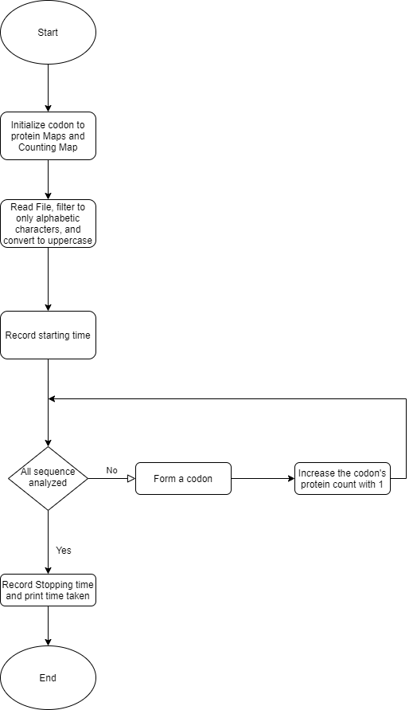

Pseudocode

sequential(string inStr)

    // Record starting time

    start <- getTime()

    for each 3 characters

        temp <- form codon from 3 characters

        // Increment protein count by 1

        countMapSeq[codonMap[temp]] += 1;

    // Record starting time

    end <- getTime()

    // Print consumed time

    print(end-start)

complexity

O(N)

7. proposed parallel algorithms (Pseudo Code, Flow chart) and their complexities

Loop-level parallelism Flow chart

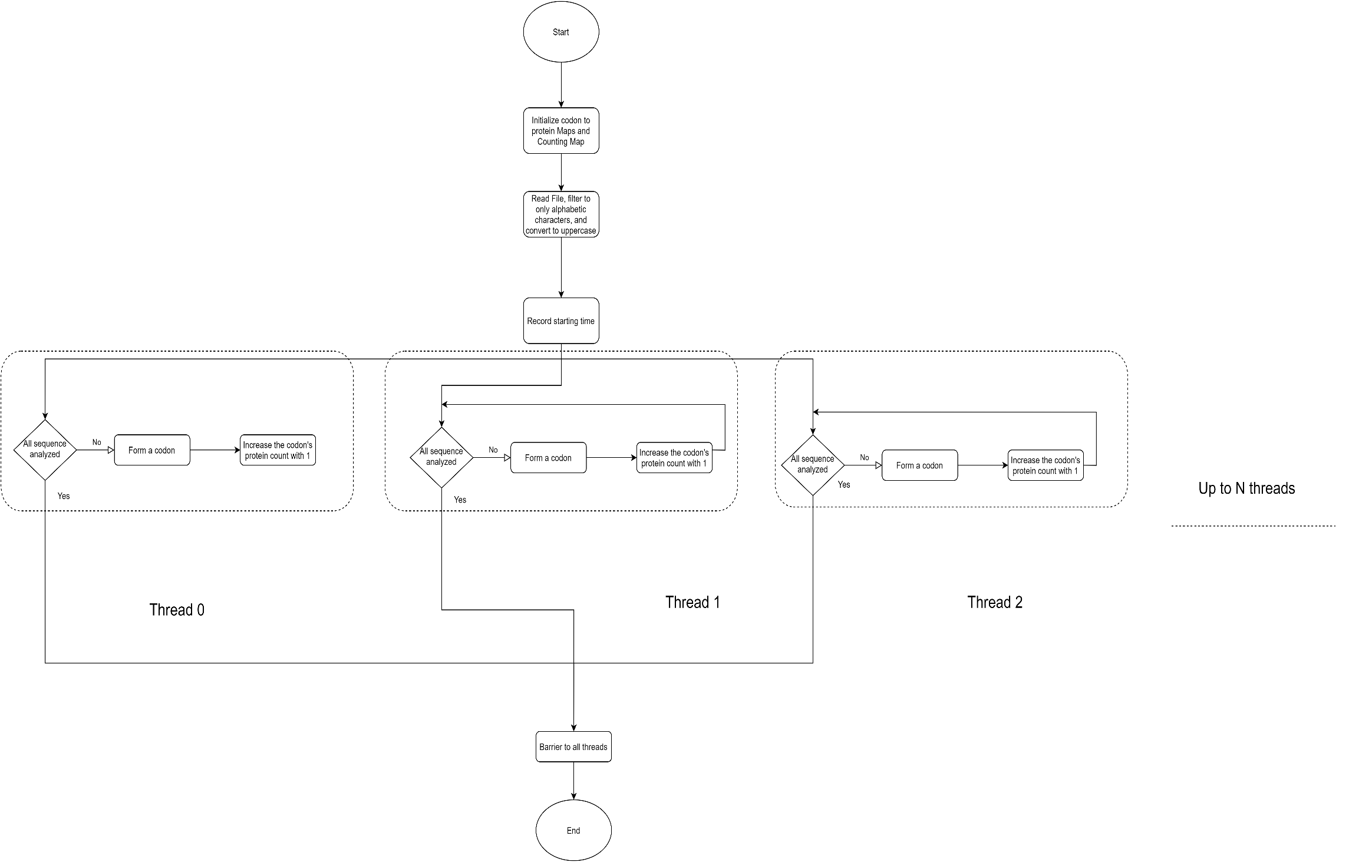

Loop-level parallelism Pseudo Code

parallel(string inStr)

    // Record starting time

    start <- getTime()

    // Parallelize loop iterations

    for each 3 characters

        temp <- form codon from 3 characters

        // Increment protein count by 1

        countMapSeq[codonMap[temp]] += 1;

    // Record starting time

    end <- getTime()

    // Print consumed time

    print(end-start)

Loop-level parallelism complexity

O(N)

Functional decomposition parallelism Flow Chart.

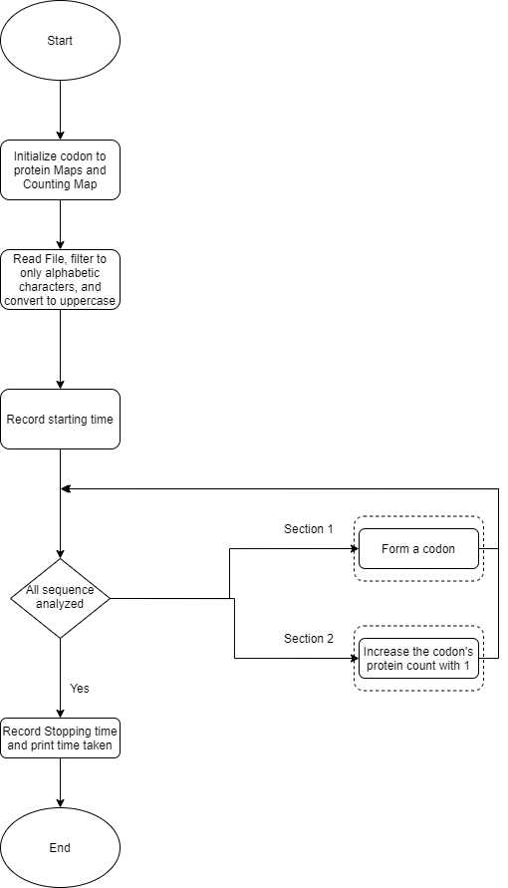

Functional decomposition parallelism Pseudo code.

parallelSections(string inStr)

    // Record starting time

    start <- getTime()

    for each 3 characters

        // Form codon in parallel section 1

        {

            temp <- form codon from 3 characters

        }

        // Increment protein count by 1 in parallel section 1

        {

            countMapSeq[codonMap[temp]] += 1;

        }

    // Record starting time

    end <- getTime()

    // Print consumed time

    print(end-start)

complexity

O(N)

8. performance evaluation (speedup, efficiency, iso-efficiency)

**Done in excel.**

9. Used H/W Specs, results, and discussions (table with time and number of threads)

Processor Intel(R) Core (TM) i7-8550U CPU @ 1.80GHz, 4 Core(s), 8 Logical Processor(s)

Installed Physical Memory (RAM) 16.0 GB

Storage Disk Model ST1000LM035-1RK172

**Done in excel.**

10. graph (time vs number of threads) for each parallel solution

**Done in excel.**

11. conclusion and comment on the results

12. appendix (code)